Managing Large Property Claims

Ed Knollmeyer
The Curators of the University of Missouri

JoAnne Flowers
The Curators of the University of Missouri

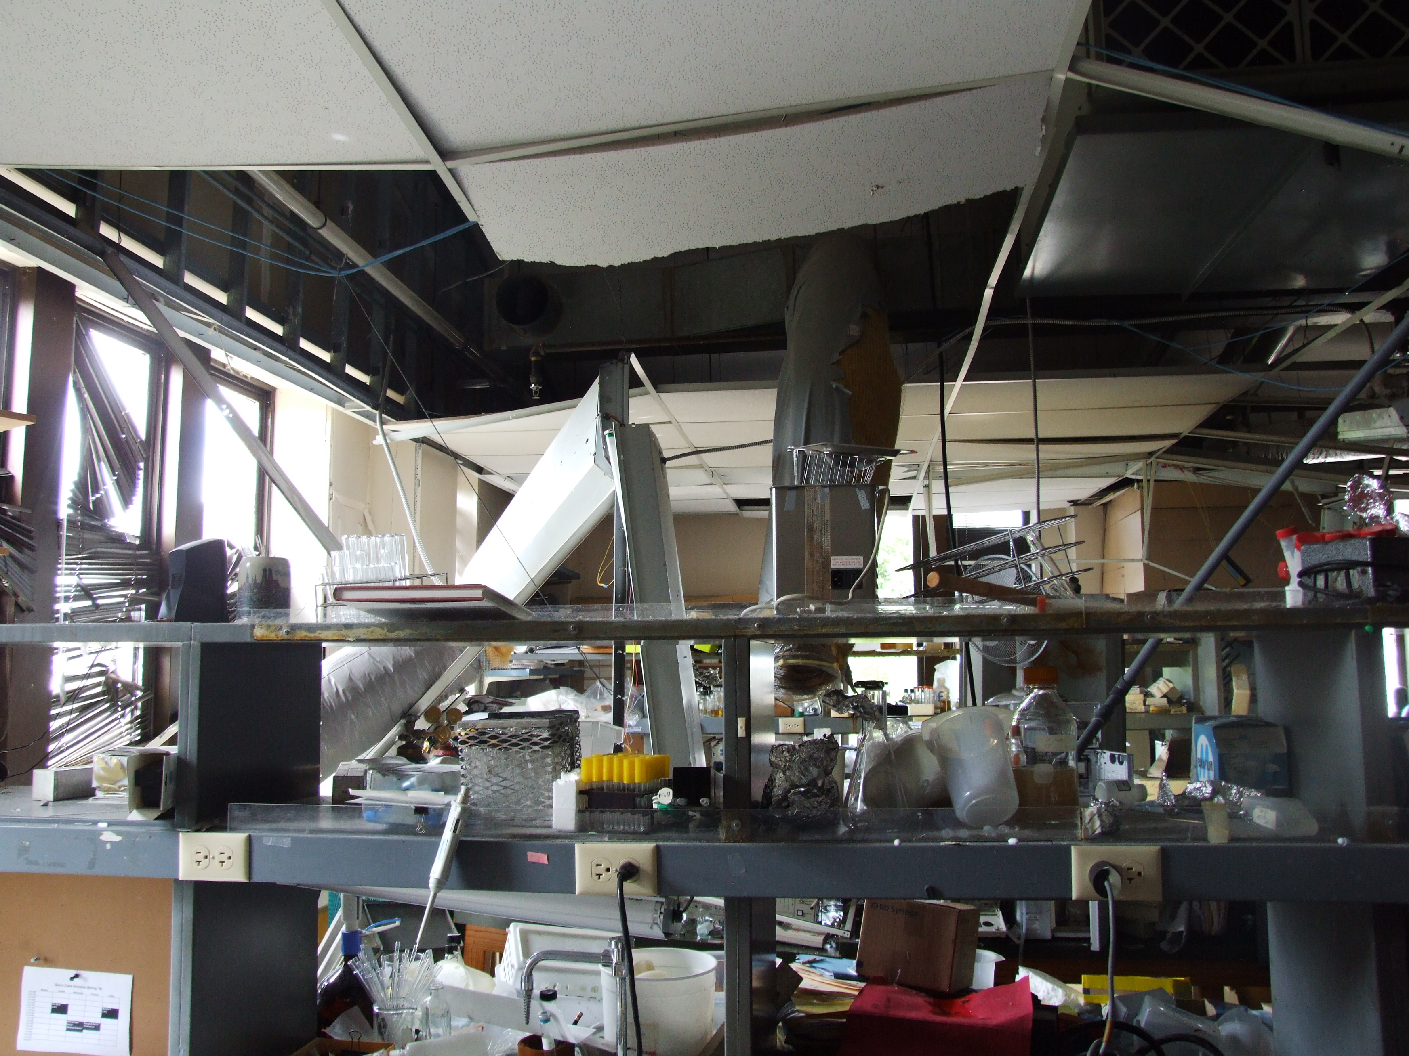

Contact Info:
Risk & Insurance Management
1105 Carrie Francke Dr
Columbia, MO 65211
573-882-8100
mgmtu@umsystem.edu
Abstract

This report provides the analysis and evaluation of the process of managing large property claims. For this purpose, we defined large property claims as those over our deductible of $100,000. The method of analysis/evaluation was to interview parties previously involved, review carrier requirements and how the existing processes had been managed. Recommendations included providing tools for departments to use in gathering the required information and to increase communication.

As a result, we developed materials, tools and a new method of managing large property claims. The materials and tools can be customized based on the number of departments, campuses, etc. involved in the loss. A SharePoint website can accommodate information related to inventories as well as the RFP for rebuild of buildings/spaces, drawings, photos, and other needed documentation. The tools being developed in advance allow shorter response time, reduction of staff preparation time (inventories do not have to be recreated each time) and versatility in managing the process.

Introduction to the Organization

The Curators of the University of Missouri has provided teaching, research and service to the citizens of Missouri since it was founded in 1839. The first publicly supported institution of higher education established in the Louisiana Territory; the University of Missouri was shaped in accordance with the ideals of Thomas Jefferson, an early proponent of public higher education.

The University of Missouri is one of the nation's largest higher education institutions, with nearly 70,000 students on four campuses and an Extension program with activities in every county of the state. The mission of the university, as a land-grant university and Missouri's only public research and doctoral-level institution, is to discover, disseminate, preserve and apply knowledge. The Risk & Insurance Management Office serves four campuses and a healthcare system for all lines of commercial insurance and claims.

The Challenge

Managing the claim process for a large property claim such as a hail storm, flood or explosion is a complicated, time consuming and lengthy task. Our University experienced many of these claims in recent years. The process was burdensome due to the number of faculty, staff and departments involved as well as the numerous steps required. As we worked through these claims, we evaluated the process for ways to improve. The challenge was how to smooth out the process, make it as simple as possible for our internal customers, and achieve a full financial recovery. The additional return on the investment was to provide better tools and service while reducing the effort of all involved. Below is a graphic representation of the major steps in the process (exhibit1).
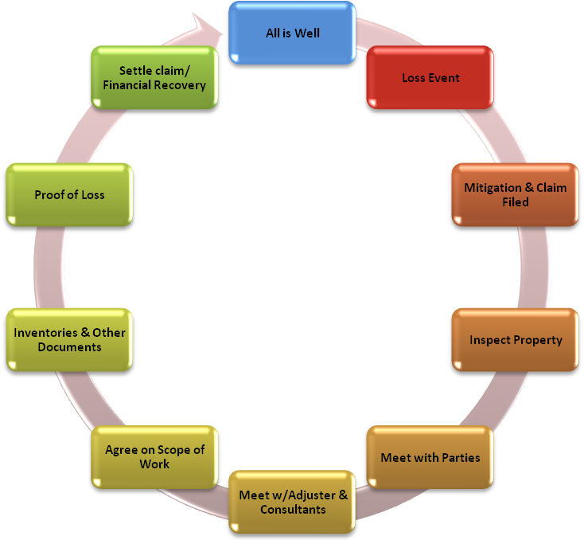

Design
Exhibit 1 – Large Property Claim Loss & Recovery Cycle
RIM & OTHER
STAFF TIME

The method of analysis/evaluation was to interview parties previously involved in handling a large claim, review carrier requirements and how existing processes have been managed. Recommendations included providing tools for departments to use in gathering the required information and to increase communication.

Our evaluation led us to the development of materials, tools and a new method of managing large property claims. The materials and tools include a guide to provide the effected units, an initial meeting to communicate the process and set expectations, an Excel workbook for collection of contents, art, business interruption and extra costs. The Excel tools and a SharePoint website can be customized based on the number of departments, campuses, etc. involved in the loss. The SharePoint site can accommodate information related to inventories as well as the RFP for rebuild of buildings/spaces, and other needed documentation such as drawings and photos.

The tools developed in advance allow shorter response time, reduction of staff preparation time (inventories do not have to be recreated each time) and versatility in managing the process. The cost included the time of one staff member for development (less than 100 hours), a few hours of faculty/other administrators input, and minor internal cost (less than $50) for the SharePoint site.

Implementation

In 2010, after experiencing a number of large property claims, we were able to implement the use of the Guide and SharePoint tools with another event. The users stated the process was straightforward to use, didn’t clog up, reduced the need to copy documents, was much smoother than the old process.

The SharePoint site allows us a portal to collect the needed documents, store the information electronically, and package the information for the insurance carrier.

The Guide is designed to clarify expectations, inform the department of the claim components and provide tools to those providing the required documentation. The Guide and other material are uploaded to the SharePoint site for easy reference.

The Excel workbook can be customized and is scalable depending upon the size of the loss, the number of departments involved, or the size of the school. The workbook consists of inventories for contents and art, and worksheets for capturing extra expenses and business interruption information. It’s all in one package so there aren’t multiple files to manage. Each worksheet has comments in the heading fields to guide the users as they complete the information. The individual worksheets can also be protected to reduce accidental or unauthorized changes, preventing one department from accidentally changing information of another.
Benefits
The benefits of the new method include increased communication, clear expectations of how the claim process will flow, timelines, and documentation required to complete the process. The revised process also provides ready tools for the effected units to use and begin work immediately with little or no delay. By implementing the use of a SharePoint site, documents are saved electronically to one location, reducing the amount of paper and effort to gather and evaluate for submission to the insurance carrier. The Excel workbook can be customized and is scalable depending upon the size of the loss, the number of departments involved, or the size of the school.

The communication and tools highlighted above lead to significant time savings and a more complete financial recovery. The time savings benefits listed above result in 10% to 20% reduction of staff time in documenting the expenses associated with the losses. In addition, since all parties are well informed regarding what expenses are recoverable and given user friendly tools that denote the level of detail required to document the expenses the financial recovery is projected to be 5% to 10% greater. It is estimated that using the large loss property tools for a $1,000,000 loss should result in $100,000 to $200,000 savings from a combination of staff efficiencies and a more complete financial recovery.

These tools were not available from other sources, so an added benefit to this analysis and process revision is having tools on hand, ready to go when an event occurs.
Retrospect
In summary, we identified a challenge to streamline and improve the handling of large property claims. The process was evaluated and tools were developed to respond to key issues. The tools are shared with internal customers during/post a large loss allowing increased communication and greater understanding of the process reducing the time and frustration for all involved.

The result of the initial implementation was very successful. In the future the guide will include sections on forensic accounting and coordinating the insurance piece with the FEMA processes.

Proposal Materials

Attached is the Guide, supplemental materials including snapshots of the inventories and screen shots of the SharePoint site.



Property
(Large Loss) Handling Guide

Table of Contents
What to do when you experience a Large Property Loss 3
The Claim Process 4
Property Claim Reporting Process Overview 4
Process Detail 4
Understanding the roles – Who’s Who 8
Appendices 10
RIM Checklist 11
Department/Campus Checklist 12
Potential Claim Items 13
Documentation Samples 14
Contents/Equipment Inventory Spreadsheet 14
Art Inventory Sample: 15
Extra Expense Sample: 16
Business Interruption Sample: 17
Inventory Directions 18
Glossary of Form Terms 21
FAQ’s 23
SharePoint Use Guide 27

What to do when you experience a Large Property Loss

Notify | - make sure all appropriate University departments are notified (i.e. Police, Campus Claims Coordinator, EHS, Risk Management, etc.)
Protect | - assure all University and non-university property are protected from further damage and make temporary repairs as necessary
Mitigate | - minimize the financial impact to your department or college by using alternate space and existing, workable equipment and supplies
Document | - start capturing all information necessary to support the property loss.

Please complete the “Damage Report” form and return to Coordinator within 24 hours.

Take photographs, if possible, prior to the removal of any debris. The photographs should accompany the loss report. Digital photographs may be e-mailed to contact@digitorysolutions.net

Separate damaged from undamaged property. DO NOT THROW ANYTHING OUT. Secure damaged property in a safe area. Retain any piece of equipment or other property, which may be the cause of the loss.

Establish a separate account to capture all expenses associated with the claim. The Proof of Loss required for the claim process includes, but is not limited to; copies of purchase orders, inventory listings, invoices, requisitions, etc. Retain all invoices, time sheets, etc., to ensure that all costs are captured and are attributable to the loss, and to prevent an overlapping of normal costs with these expenditures. Contact appropriate manufacturer services representative if necessary.

Risk & Insurance Management will provide a SharePoint site for inventories of contents, extra expense and business interruption for claim documentation for the insurance carrier. Please review guidance for each sheet. Your Department representative will be given access to the claim SharePoint site where all documentation will be posted.

**All losses are subject to a $1,000 department deductible (except boiler/machinery) **

The Claim Process

Property Claim Reporting Process Overview

When a loss occurs that may exceed the deductible, the following steps should be taken.
- Notify your campus claims coordinator and Risk & Insurance Management (RIM) as soon as possible by phone, email, or fax.
  - RIM will coordinate a meeting with affected parties as soon as practical (within 24 - 48 hours) to establish a smooth flow of information, answer questions and clarify expectations.
- Provide the following information to the extent possible:
  - name and address of loss location
  - date and time of loss
  - cause of loss
  - detailed list of damage
  - name and phone number of person(s) to contact
  - initial scope/estimate of entire loss
- Restore fire protection to full operation
- Protect your property from further loss
- Take photographs or videos of the damage
- Report all theft losses to the police, and obtain a police report case number
- Begin clean-up immediately
- Make temporary or full repairs
- Provide documentation/invoices as directed
- Claim documentation reviewed and submitted to insurance carrier
- Settle claim

Process Detail
Notification
Notify your Campus Claims Coordinator and RIM as soon as possible by telephone, email, or fax.

Restore Fire Protection (Campus Facilities)
This includes replacing sprinkler heads, arranging for temporary standby hose lines, recharging extinguishers and automatic special protection systems, capping broken lines, and getting them back into service.

Our property is particularly vulnerable to loss until all fire protection devices are working again!

Protect Property From Further Damage
In addition to restoring fire protection, common sense, and the insurance policy terms, requires action to preserve the property from further damage.

The University must take immediate emergency measures to minimize the damage. If necessary, call professional vendors for assistance. When possible, clear temporary measures and/or permanent repairs with RIM before proceeding with work. When in doubt, act as you would if you had no insurance at all.

Begin Clean Up Process
As soon as it is safe, begin cleaning, protecting, and segregating materials/contents. Separate undamaged from damaged goods and begin to segregate what can be saved.
- Dry and protect all motors and electrical equipment.
- Clean, dry, and protect machinery to prevent rust.
- Reprocess any damaged material that can be saved.
- Do not dispose of any materials until the adjuster agrees they are unsalvageable.

The adjuster usually will arrange for a salvage company to take over the property and dispose of it on our behalf. Our policy may stipulate who has control of the property and how the salvage can proceed.

Inspections
RIM may inspect the property as soon after the loss as possible with department representatives. Also, the insurance adjuster and/or other consultants may inspect the property. Photographs or videos may be taken to help document the claim.

Track Costs
This is important because in the first days after a loss and beyond it is difficult to keep track of what costs should be assigned to the claim.

Set up special work orders, job numbers, and other accounting procedures which will enable you to identify and capture all claim costs. Examples of claim cost categories are:
- protection and preservation
- temporary repairs and replacement
- permanent repairs and replacement
- extra and expediting expenses
- contents replacement
- business interruption

Be sure to review these and any other categories with Risk Management. If in doubt, please track the expense. It is a good idea to set up different categories (building, machinery, extra expense, overtime, contents, etc.) to group expenses. Make sure to separate overtime pay because regular wages are not covered.

Make Temporary Repairs
If temporary repairs are required to save, preserve, and protect the property, you must make them immediately. Use the "reasonable person" test — do what a reasonable person would do and be able to explain your rationale. Advise RIM of temporary repairs as soon as possible. Actions you take without prior authorization could subject your decision to scrutiny.

Arrange Permanent Repairs or Replacement
As time permits, before authorizing permanent repairs, attempt to obtain your adjuster's agreement via RIM on the scope of repairs. The scope of work is an important aspect of the loss; unless we agree on what needs to be done, the claim's monetary value will be in dispute and delays in settling the claim may result. All scope of repair and other documentation should go through RIM to negotiate with the insurance adjuster.

You will need to secure contractors to bid on the job. Risk Management will submit the estimates/bids to the insurance company adjusters for review. Most reputable contractors will give free estimates in the hope of obtaining the job. Some may charge for these services and those costs may not be recoverable unless agreed by the insurance adjuster. A contractor accustomed to working on insurance claims should know what type of detail the adjuster requires in the proposal. If not, arrange a meeting with the Risk Management to set up the ground rules. A bid without complete back-up details and itemization also will delay settlements.

Resume Operations
Consider whether it is practical to set up temporary facilities in your location or another while repairs are being made. If your operations include teaching, you may be able to reassign classroom space or rent space locally.

Your claim may include overtime labor, air freight, rental of special equipment, and other expenses incurred to resume operations as quickly as possible. Be careful to keep Risk Management fully informed of your actions, and always try to secure prior approval of these extraordinary expenses.

Communications
A discussion will be coordinated by RIM and all affected parties representatives to establish a smooth flow of information, clarify expectations and process.

Appoint one representative person to coordinate with RIM during the entire claim preparation process --from setting up specific work orders or similar accounting mechanisms right through the final preparation of claim figures.

See that your supervisors and foremen are notified so they can charge all cleanup, salvage, and repair labor to the proper account, and keep track of the overtime separately. It will help if individual time cards are marked to indicate the type of work involved.

Also arrange for purchase orders, invoices, and checks to reflect the special account numbers, then to be copied and uploaded to the SharePoint site to substantiate your claim.

Understanding the roles – Who’s Who

Role of Risk & Insurance Management
Risk and Insurance Management (RIM) is the department responsible for overall coordination of the insurance claim. RIM’s role is to oversee internal preparations of the claim and to be a liaison with the insurance company. It is our responsibility as an insured to investigate and document our claim. Risk Management will focus on:
- guiding the internal data gathering
- be the main point of contact/communication
- sharing this data with the insurer's claim representatives
- resolving the claim with the insurer

Role of Adjusters
After a loss is reported, an adjuster will be appointed as the Universities principal contact with the insurance company. Remember: the adjusters represent the insurer, so their primary obligation is to the insurer. Adjusters will do what they can to assist you but it is not their obligation to prepare our claim documentation.

Primary adjuster duties are to investigate, negotiate, and settle your loss. They will need to speak to the risk manager and others, inspect the damage, and gather facts about the value of the loss. With sufficient information, a coverage determination will be made. Assuming this is favorable, the adjuster will proceed toward settlement.

Adjusters can call on a wealth of background knowledge from previous losses to help you plan your actions. They also use the services of accountants, engineers, salvors, and other experts as consultants.

Ideally, to help your settlement be timely, accurate and fair, your relationship with the adjuster needs to be professional, not adversarial.

As a final note, the adjuster may arrive at different coverage positions and loss measurements than yours. Although the adjuster's decision will be strongly supported by the insurer, the adjustment process is one of negotiation — your relationship and ability to substantiate your position with facts can influence the final settlement. RIM will negotiate with the adjuster.

Role of the Department/Campus

Predetermine the Data Gathering Mechanism
Who will be responsible for gathering the data necessary to prepare the claim?
They will probably be from several departments including production, sales, accounting, and payroll. Do those individuals know their responsibilities and how quickly they must begin the process? Identifying these people ahead of time and giving them brief training on what recordkeeping will be required will make your claim easier to document, substantiate, and collect.

Make Certain Vital Records Will Not Be Destroyed
Some documents are stored on-site and may not be duplicated elsewhere.
Problems will result if you have to recreate evidence of what existed before the loss without an appraisal, inventory, or ledger. If you now store valuable documents on the premises, they should be in a fireproof area. However, the best procedure is to keep a copy of these documents at an off-site location. Examples include:
- appraisals
- blueprints, plans, and specifications
- photographs
- property records
- inventory records
- financial records

Consider a Detailed Equipment Inventory
Machinery and equipment claims can be complicated. If there is no formal appraisal, learn what types of lists exist to document machinery and equipment. Ideally you will have a detailed description of each machine with its manufacturer, age and cost, including the cost of freight, installation, accessories, attachments, and modifications.

Photos or videos can show the adjuster what these machines looked like when operational. Be aware that the book value of machinery and equipment can be written off and disappear from capital asset ledgers, but they still have a value for claim purposes.

Appoint Key Contacts
A serious loss necessitates a series of important decisions on such matters as salvage, expediting repairs, or resuming operations. Top-level management must make some of these decisions. To function effectively during the emergency, be sure to designate who will be responsible for coordinating and communicating with Risk Management and the insurance adjuster.

Your list should include a primary and alternate contact. These representatives should keep in continual contact with Risk Management and the Campus Claim Coordinator.

Appendices
Appendix 1

RIM Checklist
Get info:
- Contact name/number – who will be the point person on site?
_________________________________________________
- What happened?
- Location of loss _________________________________
- Date and time of loss _____________________________
- Type of loss (fire, explosion, etc.) ___________________
- Property involved (building, contents, EDP, etc.)
______________________________________________
- Extent of damage (dollar estimate) __________________

- Current status?
_________________________________________________

- What is the operation in building? _____________________
- Is it still usable or not? ___________________________
- Alternate location needed or available?
______________________________________________
- What resources are needed right now?
_________________________________________________

- Expect any business interruption expense? _______________
  - If so, to what extent? _____________________________

Remind them to:
  - Mitigate to the best of our ability to reduce further loss
  - Take photos to document as much as possible
  - Have finance staff set up MoCode to capture claim expenses

Appendix 2

Checklist

Initial Process:
- Take steps to reduce loss as much as possible
  - Mitigation strategies/actions
    - Restore fire protection (sprinklers, hoses, etc.)
    - Make temporary/emergency repairs
    - Secure vital records and ledgers
    - Construct temporary structures
    - Convert existing space
    - Purchase service from outside vendors
    - Begin salvage and clean-up (do not throw anything out, set aside)
    - Expedite long-term repairs to essential equipment
- Take photos to document as much as possible,
- Take steps to secure area – control access to area, building, etc
- Provide RIM with contact information (primary onsite contact and 1 alternate)

After area is secured and claim reported to RIM:
- Participate in meeting with RIM and other applicable parties – discuss process, claim, etc.
- Acquire copies of police or fire reports
- Assemble blueprints, floor plans, drawings
- Do not throw any damaged items away (including items in refrigerators and freezers) – one exception = BIOHAZARD MATERIALS
- Provide detailed narratives, photographs, vendor reports, etc. to support the disposition of damaged items
- Track all expenses related to work (set up separate account for capturing all costs)
  - Set up special work orders, job numbers, or accounting procedures
  - Obtain repair estimates or appraisal documents from contractors for structural damage
  - Copy and store invoices for completed work or cleanup
  - Complete contents inventory
    - Get replacement invoices for contents/equipment
    - Gather asset records (physical or perpetual) to support damaged property
- Purchasing Like Kind: Upgrades can only occur after validation by insurance company and if PI pays the difference
- Consideration for lost grants/contracts
- Financial impact due to delayed application or lost revenue

Potential Claim Items

Expense Group | Expense
Business Interruption | Rental of temporary premises
Business Interruption | Rental of temporary equipment
Business Interruption | Relocation expenses (to and from)
Business Interruption | Preparation of temporary premises
Business Interruption | Telephone and data processing installations
Business Interruption | Heat, light, and power (temporary location)
Business Interruption | Temporary classrooms
Contents | Desks, computers, chairs
Contents | Equipment not affixed to the building
Extra Expense | Security service
Extra Expense | Extra engineering service
Extra Expense | Hotels - Temporary Living
Extra Expense | Renting Equipment Time
OT Labor | Overtime payroll
Building | Repairs and maintenance
Supplies/Materials | Supplies

Appendix 3

Documentation Samples

Contents/Equipment Inventory Spreadsheet

SharePoint site will be set up for all documentation and inventories.

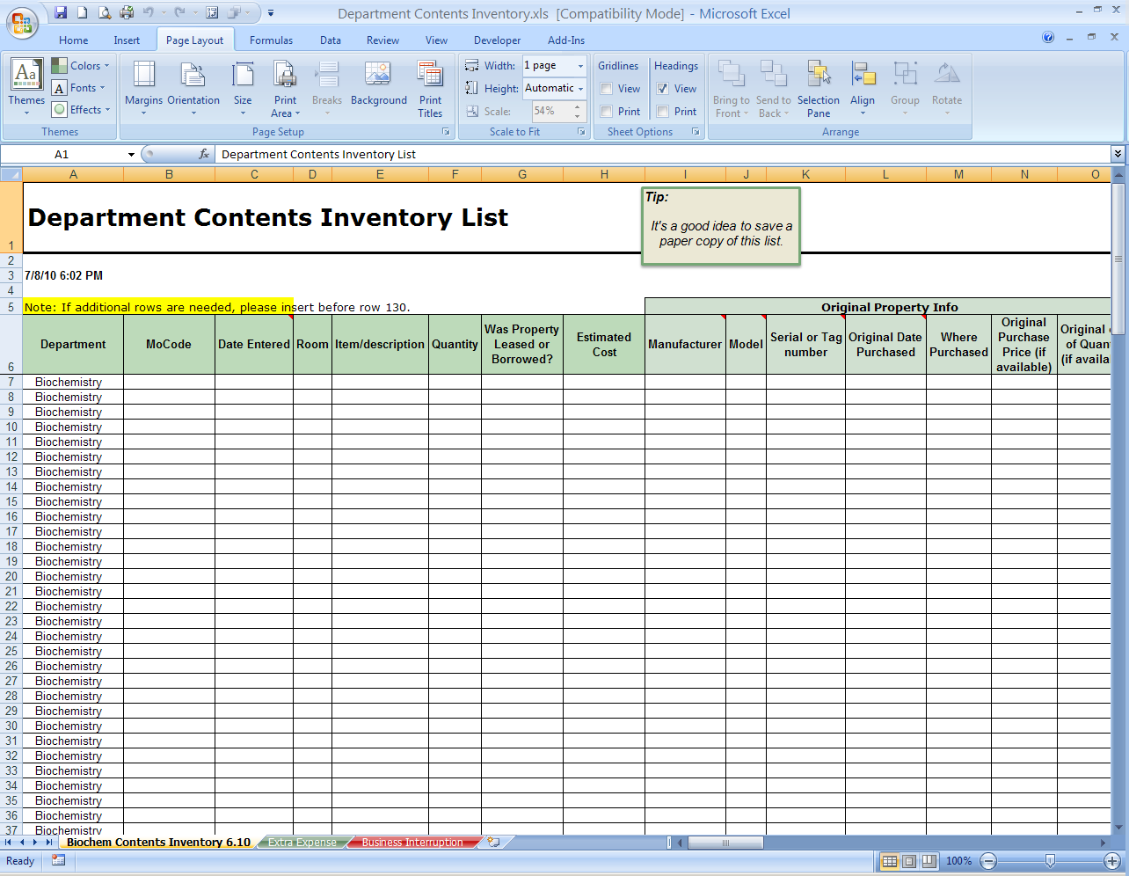

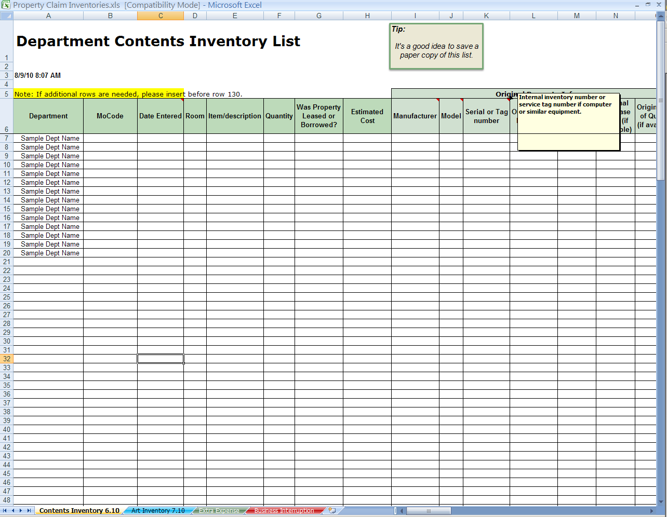

Art Inventory Sample:

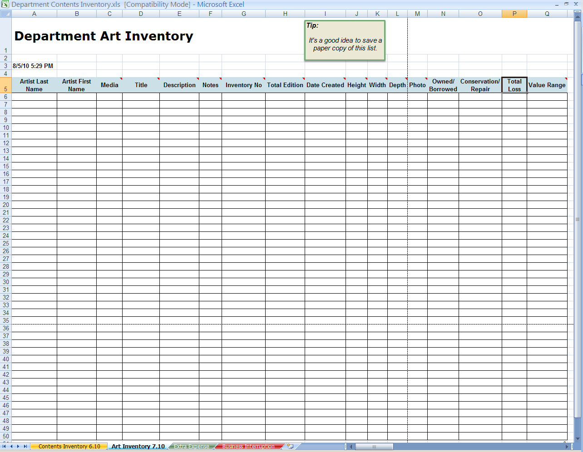
Extra Expense Sample:

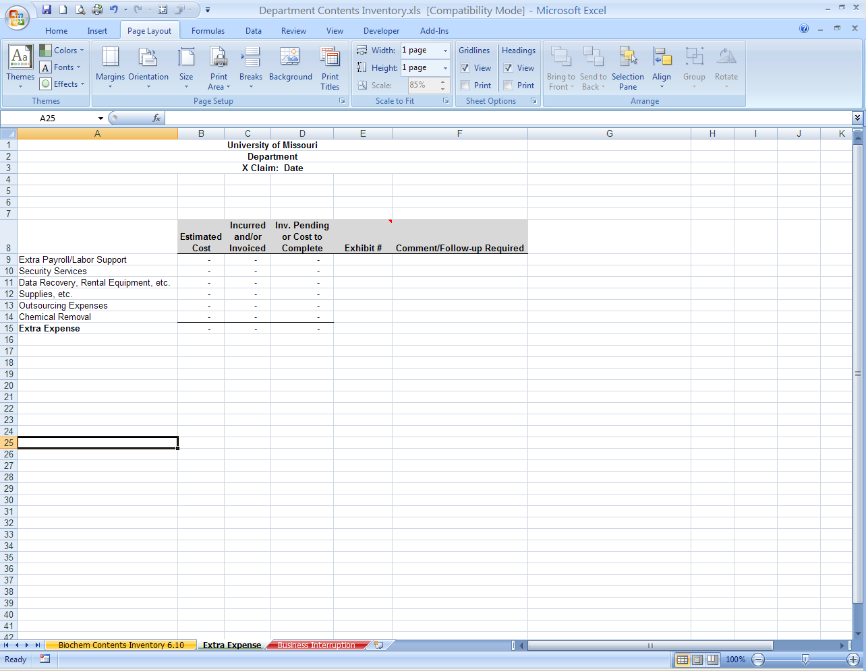

Business Interruption Sample:
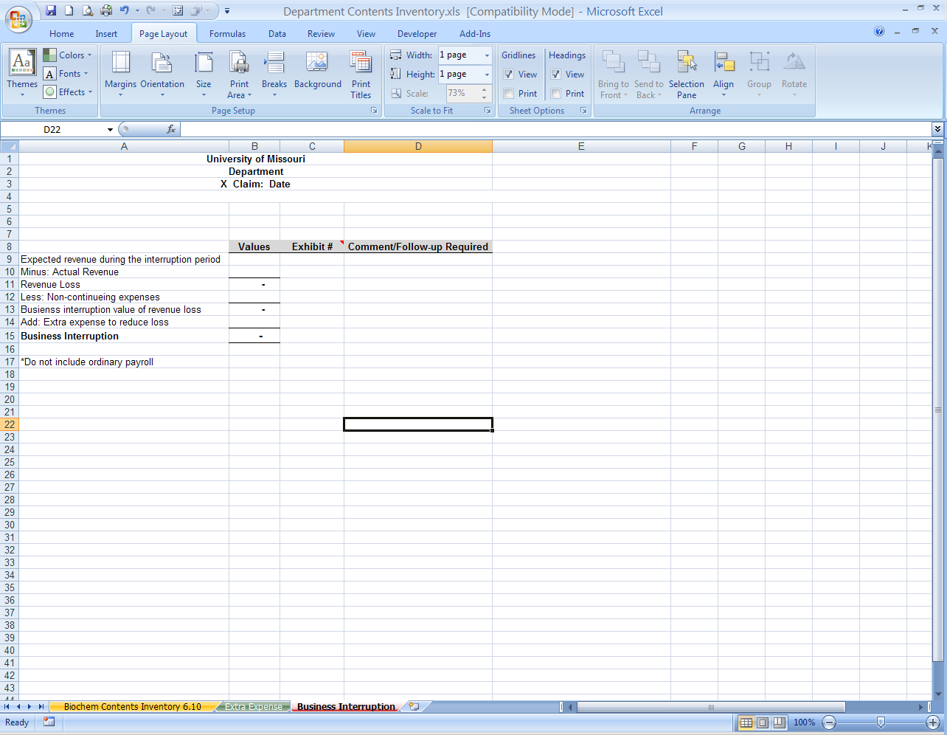

Appendix 4
Contents Inventory Guidance
*Each Department should appoint 1 primary contact for the contents list submission. Please complete the Contact Information; name, phone, and email. The cost value will populate for you as you complete the form.
*We recommend that you request each office/room occupant to provide you a list of items in the space, with as much detail as recollection allows. Example: item 1 - wood desk, approx. 5 foot long, 2 drawers on each side and keyboard tray in the middle/ replaced with wood desk…
*There are hidden rows between 34 and 135 in case you need them or you may insert additional rows.
*Multiples of the same item; if the same cost, etc. can be included in 1 row. Example: purchased 5 chairs, one invoice, one row on report.
Column A (Department)
Please complete the Department name. This can be copied down for other items as well.
MoCode – PeopleSoft code associated with the claim
Column D (Room)
Please specify which office/room/space the items following relate.
Pale Green section: Original item information
Compile original purchase supporting documentation that shows what was purchased, when it was purchased, and the cost of the items. Please label each invoice or supporting documentation with a number to correlate with the Excel spreadsheet.
*Quantity relates to the number related to the claim and should be less than or equal to the quantity on the supporting documentation.
Pale Blue Section: Repair information
Compile repair documentation and label as exhibits to correlate with the Excel spreadsheet as well.
Tan Section: Replacement information
This includes the item and description, quantity and supporting documentation. Receipts, invoices, vouchers, purchase confirmations or other supporting documentation that indicates what was purchased, when it was purchased and the cost of item must be included in the submission.
*Quantity relates to the number related to the claim and should be less than or equal to the quantity on the supporting documentation.
Gold Section: Upgrade information
The portion of expense associated with the “upgrade” rather than straight replacement of an item. This will be the responsibility of the University or department
Cost Center
MoCode related to Damage.
Exhibits
Please label all supporting documentation in the upper right hand corner to correlate with the spreadsheet for original, repair and replacement of each item. Multiple items on one supporting document is fine, just refer to the item on each row that it applies. Example, row 5, 6 and 7 were all purchased together and are on the same invoice labeled Exhibit 5; type in 5 in each row. For replacement items, you can list the voucher number associated.
Before Submitting, please remember to:
*Verify each row is complete and has supporting documentation.
*Please upload updated spreadsheet and exhibits to the SharePoint site. If you cannot add supporting documents electronically please send a paper copy in numerical order to Risk Management, Old Alumni Center, 1105 Carrie Francke Dr, Columbia, MO 65211.
*Please keep a copy for your departments records.
*There is a glossary within the spreadsheet to explain the context of the information being asked for in the form for your reference.

Inventory Directions
UM Property Claim - Business Interruption Guidance
The key tasks in developing your business interruption loss are to:
- Identify the period of interruption and determine what would have happened if
the loss had not occurred
- Compare that projection with what actually did happen. The difference will be
your loss.
A simple approach to calculating the claim is to measure the revenue lost and deduct
non-continuing expenses.

Your business interruption claim — in basic form — might look like this:
Expected revenue during period of interruption $500,000
Less: Actual Revenue - $200,000
Revenue Loss $300,000
Less: Non-continuing expenses* - $225,000
Business interruption value of revenue loss $ 75,000
Add: Extra expense to reduce loss + $ 15,000
Total business interruption claim $ 90,000

Exhibits
Please label all supporting documentation in the upper right hand corner to correlate with the spreadsheet for original, repair and replacement of each item. Multiple items on one supporting document is fine, just refer to the item on each row that it applies. Example, row 5, 6 and 7 were all purchased together and are on the same invoice labeled Exhibit 5; type in 5 in each row. For replacement items, you can list the voucher number associated.
Before Submitting, please remember to:
*Verify each row is complete and has supporting documentation.
*Please upload updated spreadsheet and exhibits to the SharePoint site. If you cannot add supporting documents electronically please send a paper copy in numerical order to Risk Management, Old Alumni Center, 1105 Carrie Francke Dr, Columbia, MO 65211.
*Please keep a copy for your departments records.
*There is a glossary within the spreadsheet to explain the context of the information being asked for in the form for your reference.

UM Property Claim - Extra Expense Guidance
Potential Extra Expense Items
- Rental of temporary equipment
- Relocation expenses (to and from)
- Preparation of temporary premises
- Overtime
- Transportation expenses

Exhibits
Please label all supporting documentation in the upper right hand corner to correlate with the spreadsheet for original, repair and replacement of each item. Multiple items on one supporting document is fine, just refer to the item on each row that it applies. Example, row 5, 6 and 7 were all purchased together and are on the same invoice labeled Exhibit 5; type in 5 in each row. For replacement items, you can list the voucher number associated.
Before Submitting, please remember to:
*Verify each row is complete and has supporting documentation.
*Please upload updated spreadsheet and exhibits to the SharePoint site. If you cannot add supporting documents electronically please send a paper copy in numerical order to Risk Management, Old Alumni Center,1105 Carrie Francke Dr, Columbia, MO 65211.
*Please keep a copy for your departments records.
*There is a glossary within the spreadsheet to explain the context of the information being asked for in the form for your reference.
Appendix 5

Glossary of Form Terms

Actual cash value
Cost of replacing damaged or destroyed property with comparable new property, minus depreciation and obsolescence. For example, a 10-year-old sofa will not be replaced at current full value because of a decade of depreciation.

Building
Building name

Business Interruption
Generally, business interruption insurance provides reimbursement for lost net profits and necessary continuing expenses.

Campus
Campus name

Contents
Coverage is for a business's personal property items that are movable, that is, not attached to the building's structure such as inventory, machinery, equipment, furniture, and fixtures.

Department
Business unit responsible for and/or associated with the items, name please.

Event
Refers to the specific Property damage that occurred

Exhibit Number
Assign a number to each exhibit to match with item on worksheet or include a voucher number to match with item in row.

Extra Expense
Extra Expense insurance covers such expenditures over and above your normal monthly expenses. For instance, If your building was rendered untenantable by fire or any other insured peril, it would probably be necessary to secure other quarters to continue your business operations. However, the use of such buildings would undoubtedly involve many extra expenses, such as rent, installation of telephones, etc.

Item Description
Please be as thorough as possible: size, material, number of drawers, etc

Like Kind and Quality
This is a method of replacing specific property which can no longer be repaired or purchased. The replacement item should be of functional equivalent to the damaged or lost item.

Manufacturer Brand

MoCode Cost Center University cost center assigned.

Model Type/series

Original Documentation
Receipt, invoice, voucher or purchase confirmation or other supporting documentation that indicates what was purchased, when it was purchased and the cost of item.

Original Date Purchased
Acquisition Date of the original item

Property Damage
Physical damage to tangible property; including all resulting loss of use of that property.

Replacement cost
The current price that must be paid to replace the damaged or lost item that is brand new and similar in type and quality (aka like kind and quality)

Replacement Documentation
Receipt, invoice, voucher or purchase confirmation or other supporting documentation that indicates what was purchased, when it was purchased and the cost of item.

Resources
Suggested resources for supporting documentation:
- Department fiscal records
- University inventory for items >=$5,000
- Instruction guides for manufacturer and model information
Room
Specific space where property was located; office number/name, classroom, etc

Serial Number/Inventory Number
Inventory or service tag number - internal

Service Tag
Some equipment, such as computers, has a service tag, usually 7 digits

Upgrade
If the University decides to “upgrade” by replacing a damaged item with a newer or nicer item, the expense associated with the “upgrade” will be the responsibility of the University or department.
Appendix 6

FAQ’s
(Generic Version- update for specific claim event)

What is the process for filing a claim for Event losses?
The Risk & Insurance Management Office will be working with the insurance carrier and will assist departments in identifying and submitting expenses associated with the Event. The first step is a careful assembling of a detailed and complete inventory list of your lost property and damages. Disaster restoration vendors are circulating to assist in the inventory process. Risk & Insurance Management will be including your department’s inventory information in the overall insurance claim.

How do we document specific losses for our claim?
All losses must be documented, with detail about the lost or damaged equipment, amount of supplies damaged, and/or any building repairs needed. Inventory records, purchase receipts, or other proofs of costs incurred are helpful. Photographs or video of the facility pre-Event would be helpful, too, if you have them. Photographers will be allowed in the buildings to record equipment that cannot be salvaged. The department should assist with this recording process. The photos will be used to help determine replacement cost.

What is the process for filing a claim for contents related to Event losses?
All losses must be documented, with detail about the lost or damaged equipment, amount of supplies damaged, and/or any building repairs needed. Inventory records, purchase receipts, or other proofs of costs incurred are helpful. Photographs or video of the facility pre-Event would be helpful, too, if you have them. A SharePoint tool has been posted to our website for Departments to access, complete and submit electronically with supporting documentation attached.

What is the process for completing the Department Contents Inventory form?
A SharePoint site has been set up and access granted to the primary contact for each department. If you need access to the site or have questions, please contact Risk & Insurance Management (mgmtu@umsystem.edu or 573.882.8100. Guidance on how to complete the form is included on the main page. Copies of requisition and/or voucher numbers are sufficient for documentation on repair and replacement purchases.

What qualifies as supporting documentation?
Supporting documentation includes receipts, invoices, requisitions, vouchers or purchase confirmation or other documentation that indicates what was purchased, when it was purchased and the cost of item. Documentation for computers and similar equipment should include the component detail to confirm the replacement equipment of like kind and quality. Requisition and/or voucher numbers are sufficient for documentation on repair and replacement purchases.

How is Like Kind and Quality determined?
Like Kind and Quality means the replacement item/property is the functional equivalent, no better or less, than the original property. If an item is no longer being sold, determine what the available equivalent is for reference and cost.

Is there insurance coverage if the Department was able to repair the property internally?
Repairs completed internally are not covered except for parts/materials. If the repair required staff over-time, the expense should be captured in your documentation.

Temporary vs. Replacement items –
Furniture and other property that was purchased for temporary use and will not be used in your permanent space are considered temporary and not replacement. These temporary items should be documented as extra expense/temporary measures, with justification, but not included as a replacement purchase for the contents inventory. An example is the purchase of several tables rather than desks to due space or time constraints. The desks ordered later will be replacement items and should be included in the Department Contents Inventory.

What if we want to upgrade an item damaged in the Event? Will insurance cover that?
The purpose of insurance is to put the University in the same financial position as before the event occurred. If the department/university wants to upgrade in any way (called “betterment” in insurance terms), the cost will be borne by the department/university. That is, if an item can be repaired, the insurance carrier will owe for the repair, or for an equivalent replacement if no repairs are possible. If however, the University decides to “upgrade” by replacing a damaged item with a newer or nicer item, the expense associated with the “upgrade” will be the responsibility of the University department. An example is the replacement of a camera. The damaged item was a 35mm and a “like kind and quality” item is available; however, you’ve decided to purchase a digital with numerous additional features that is $75 more. The difference in cost of $75 is upgrade cost.

Are my personal items covered by University insurance?
The University’s insurance policy does not cover personal items lost in the Event. Claims for personal items lost in the Event should be submitted to your personal homeowner’s or renter’s insurance carrier.

What is the process for filing a claim for missing/presumed stolen property related to the Event?
Please complete the property loss form and note that you have searched the building to confirm it wasn’t relocated and submit to Risk & Insurance Management. For this instance, you will not be asked for a police report. For other cases not related to the Event, please follow the regular process of obtaining a police report and filing as noted on the website http://www.umsystem.edu/ums/departments/fa/management/risk/coverages/self.shtml
How does our department get permission to examine our area and/or our stuff to see about damages?
Department staff will have the opportunity to inspect damaged property. The (XX) is coordinating this effort. Equipment needs to be evaluated to determine if repair or replacement is needed. The Risk & Insurance Management and Procurement departments will work to assist you; please be patient with us, as we are trying to help many people at once.

We’ve got some items that may be salvageable, but we’ll need to spend some money right away to save them from further damage. Is this an insurable expense?
If you can prevent further expensive damage by spending a little extra money now—buying a tarp to protect equipment left outside from rain/sun, or freeze-drying valuable books to avoid mold damage, for instance—it is both common sense and likely an insurance-reimbursable expense to do so. Start plans to do it right away, and contact Risk & Insurance Management as soon as possible to confirm the preservation expense is insured.

What kind of insurance is available to help with Event losses?
The University of Missouri is self-insured up to $100,000 and purchases excess insurance for property loss and business interruption.

How is our damaged/lost property valued for the insurance claim?
Insurance coverage is meant to help restore the University to the same financial condition as prior to the event (the Event). The University will be able to file a claim for “replacement value” for the damaged equipment or buildings. Damaged contents will be inventoried by the disaster restoration vendors and the insurance company will determine any salvage value.

What valuation is insurance likely to pay?
Insurance will first owe the cost for repairs, if repairs are possible. If an item cannot be repaired, and the item is to be replaced, the insurance carrier will owe for the replacement either for the exact same item or one of “like kind and quality” to the item lost—equipment that is the most functionally equivalent to that damaged or destroyed. If an item was damaged or lost but will not be replaced, the insurance carrier will owe the Actual Cash Value basis (depreciated value) of the damaged item.

If our stuff is damaged, can we just throw it out and file a claim for new replacements?
Not if you want to file a claim for the property. Equipment must be repaired, rather than replaced, if the cost to do so is lower. The insurance company determines if equipment can be repaired, so don’t throw things away if you will be making a claim for it until an insurance company representative has had a chance to examine it. Equipment that is being replaced because it cannot be repaired must be inventoried and then approved before it is discarded. (The insurance company also has the option to take damaged property as salvage, in exchange for payment of replacement cost.)

We had to purchase supplies to make it through the Event period. Can we file for an insurance claim for these supplies?
Supplies that are purchased because you don’t have access to your building/area are not a reimbursable expense. They would become part of your ongoing stock. On the other hand, if supplies were damaged by the Event, an insurance claim should be requested. Documentation regarding the replaced inventory will be requested, so save your receipts!

We can’t get at some stuff in Event affected buildings that we need urgently. How can we go about obtaining replacements very soon?
If supplies cannot be accessed in buildings affected by the Event and are needed for the current or next session, replacement supplies should be ordered right away. The Procurement Department will assist you. Save your receipts for consideration as part of the insurance claim.
Appendix 7

SharePoint Use Guide

Click on the link in the email you receive. This will take you to the SharePoint site log on (screen shot below)

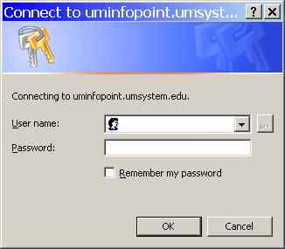

Make sure to use your full email address…
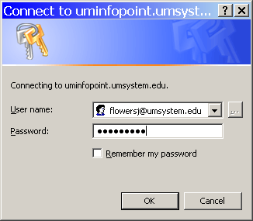

The first screen appears like this:
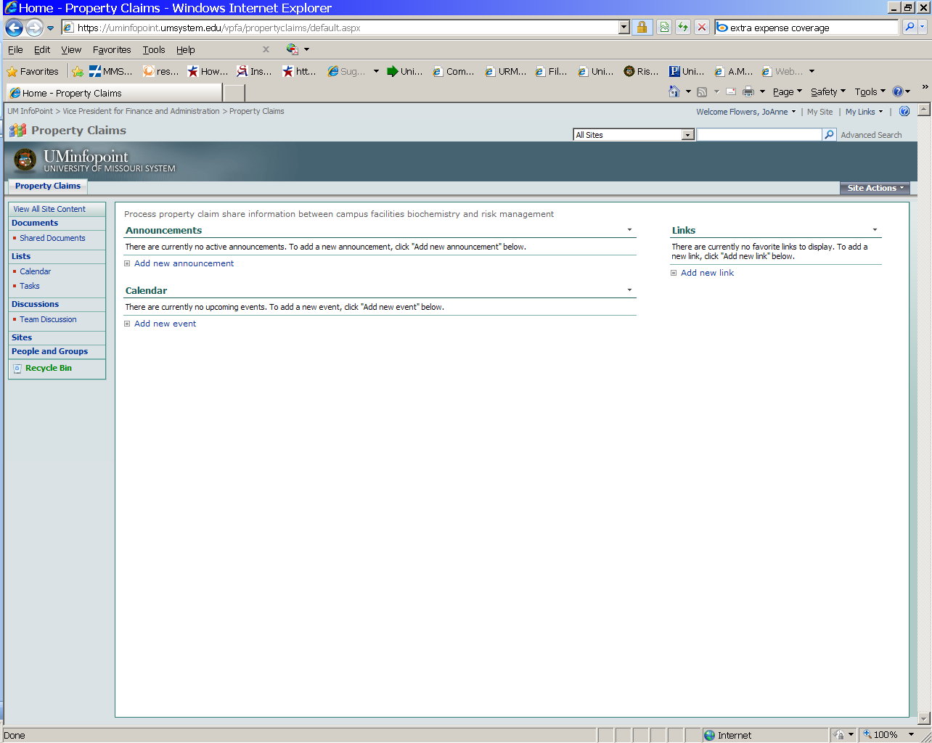
Any changes and updates can be viewed under “Announcements”.

By clicking on the “Shared Documents” quick launch link, you will be taken to the location with the various folders including Department Contents Inventory and Support Documentation, as shown below:
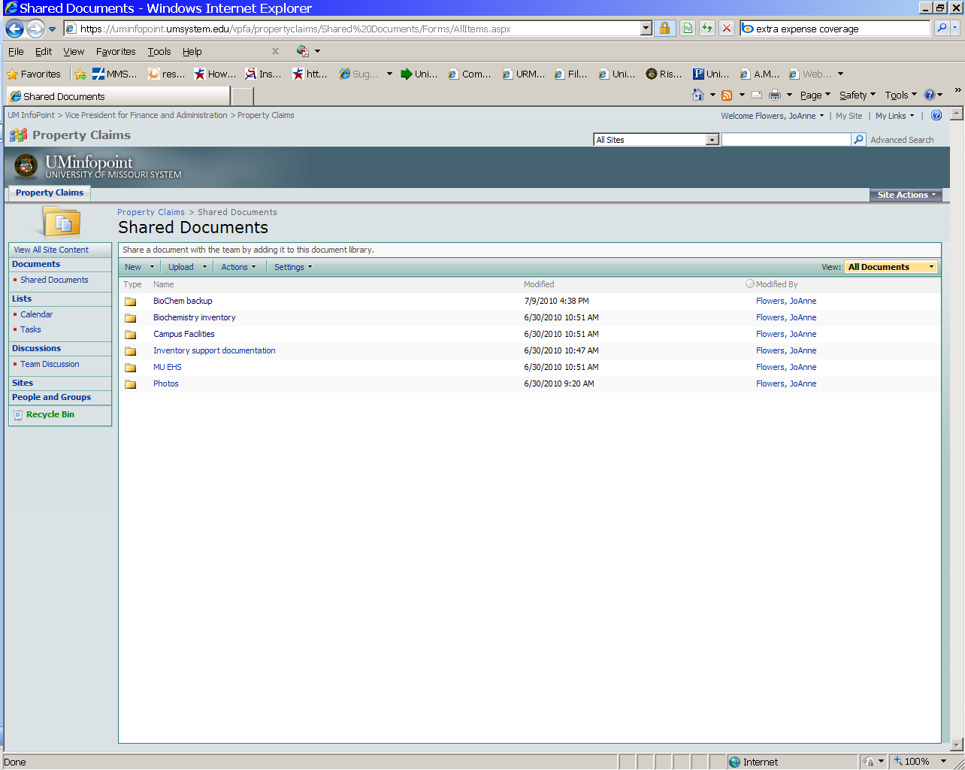

If you select Inventory Support Documentation, you’ll see the inventory directions or photos for the list of all available shots. These photos may be helpful in completing the inventories.

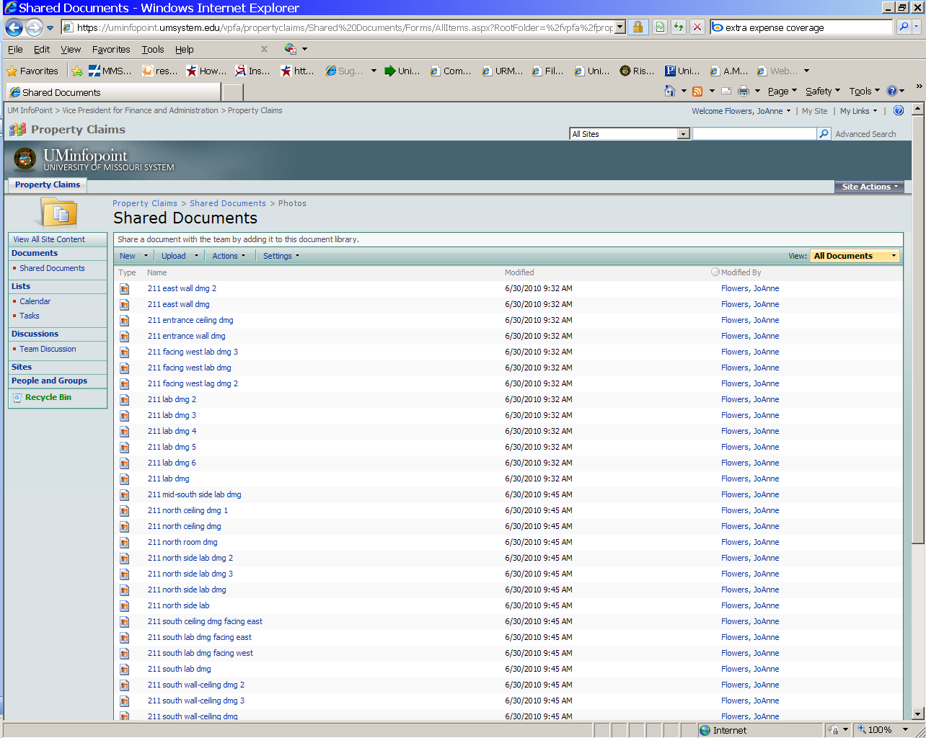
If you left-click on the name of the document, the document will open for you to read (perhaps print a copy if desired) and follow.

If you right-click on the name of the document, a list will appear and you should chose “Edit with Microsoft Excel”. This action will open the file and you will be able to enter in the information relating to your damaged contents inventory that was replaced or repaired. If there is more than one department involved in the loss, each will have their own inventory as applicable user name/password.

Enter your user name and your regular password to open the spreadsheet. Once the workbook is open, find your worksheet tab. They are in alpha order from left to right. Select your worksheet, then go to Data menu:

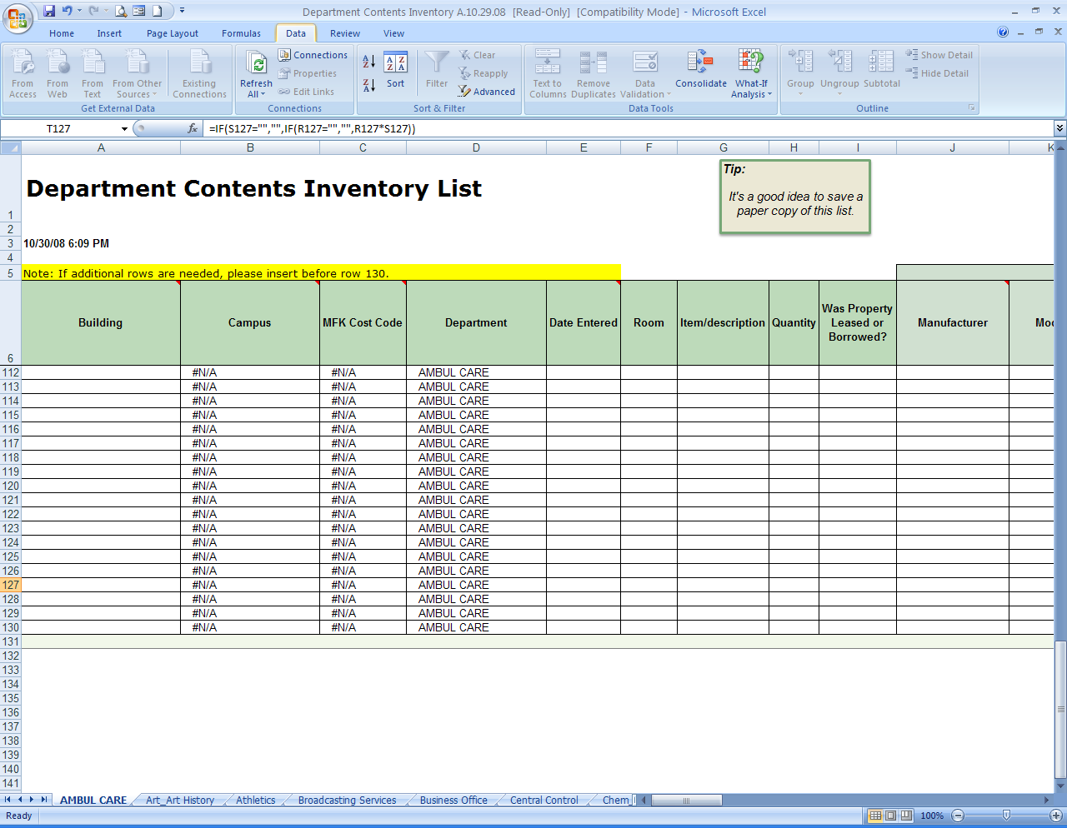

Working from left to right, select your building from the drop down to begin. This will populate the campus and cost code. Department has been prefilled but you can changed if the campus and cost code. Department has been prefilled but you can changed if needed.

Once in the Review menu, select unprotect & enter the password supplied for your
Department.

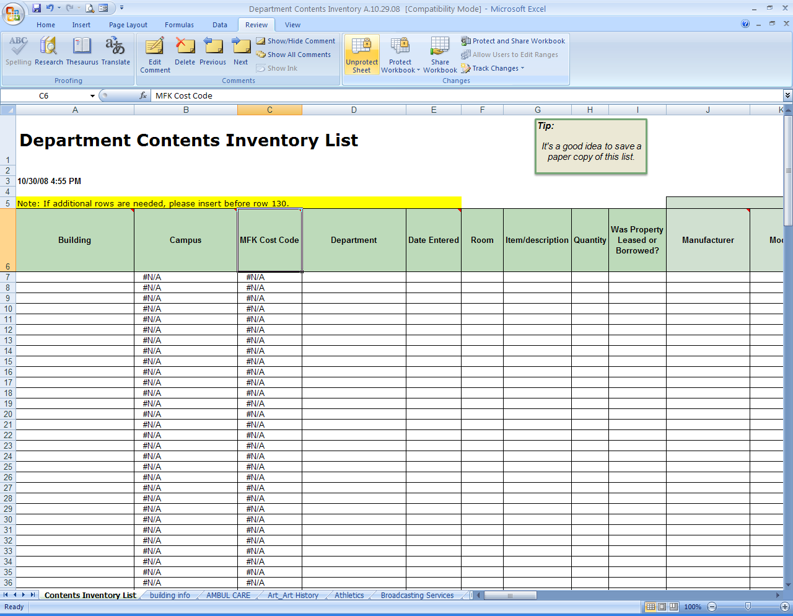

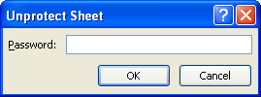

This will allow you to enter the information.

Completing the worksheet:
Working from left to right, select your building from the drop down to begin. This will populate the campus and cost code. Department has been prefilled but you can changed if needed.

Column D – Please specify which office/room/space the items following relate.
Pale Green section: Original item information
- Compile original purchase supporting documentation that shows what was purchased, when it was purchased, and the cost of the items. Please label each invoice or supporting documentation with a number to correlate with the Excel spreadsheet.

- Quantity relates to the number related to the claim and should be less than or equal to the quantity on the supporting documentation.

Pale Blue Section: Repair information
- Compile repair documentation and label as exhibits to correlate with the Excel spreadsheet as well.

Tan Section: Replacement information
- This includes the item and description, quantity and supporting documentation. Receipts, invoices, vouchers, purchase confirmations or other supporting documentation that indicates what was purchased, when it was purchased and the cost of item must be included in the submission.
- Quantity relates to the number related to the claim and should be less than or equal to the quantity on the supporting documentation.

Gold Section: Upgrade information
- The portion of expense associated with the “upgrade” rather than straight replacement of an item. This will be the responsibility of the University or department

Cost Center
- MoCode related to the Damage.

Exhibits
- Please label all supporting documentation in the upper right hand corner to correlate with the spreadsheet for original, repair and replacement of each item.
- Multiple items on one supporting document is fine, just refer to the item on each row that it applies.
- Example, row 5, 6 and 7 were all purchased together and are on the same invoice labeled Exhibit 5; type in 5 in each row. For replacement items, you can list the voucher number associated.

When you want to log out, change the protect status again by selecting Review and Protect Form. Use the password supplied to lock your worksheet. Then Save and Log out.

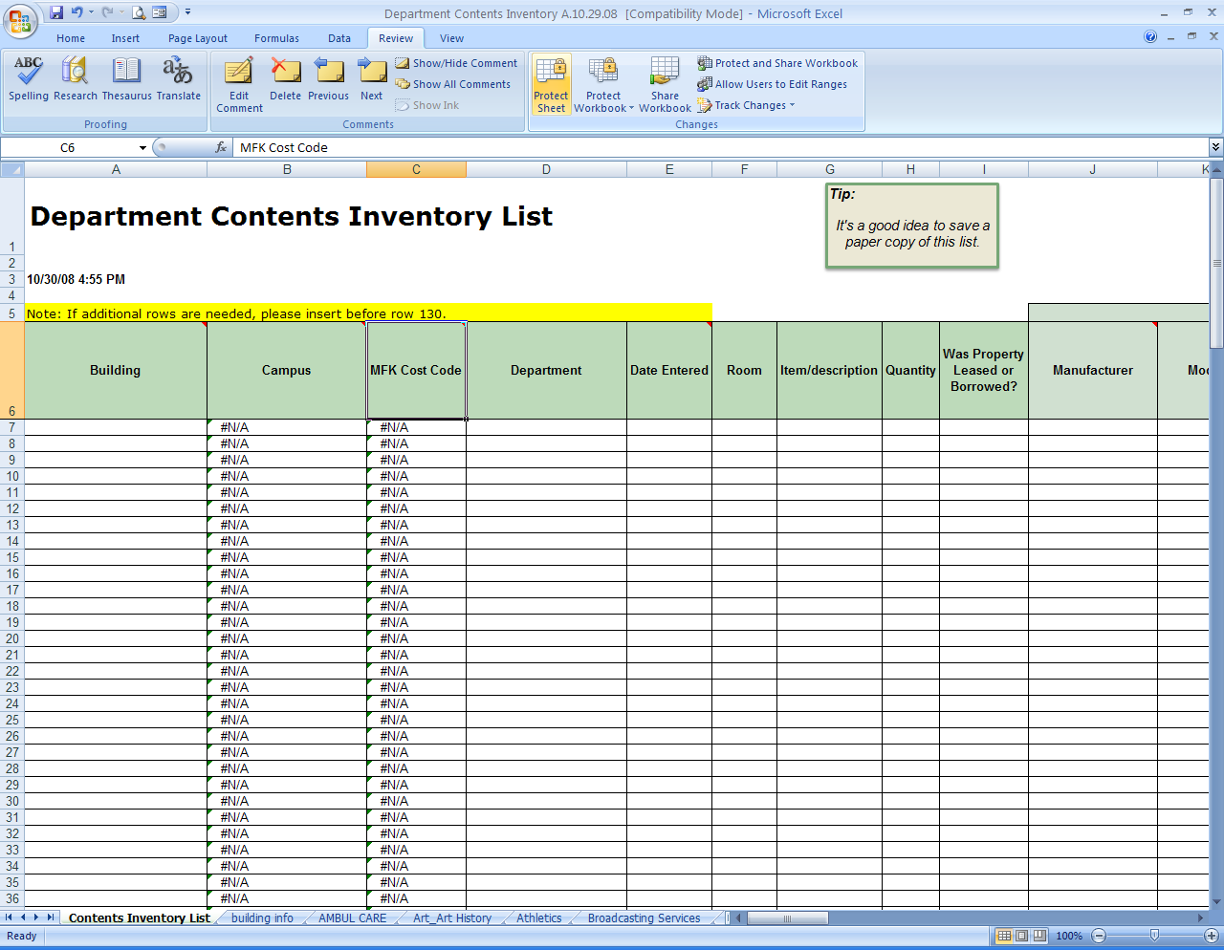

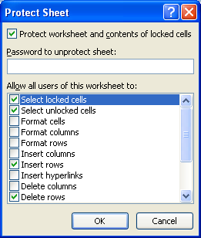

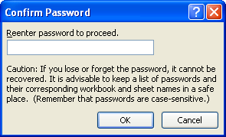

Please remember to:
- Verify each row is complete and has supporting documentation.
- Submit the electronic supporting documents as attachments in SharePoint. If you do not have documents electronically, please send a paper copy in numerical order to Risk Management.
- Please keep a copy for your Departments records.

Resources

Material for the Guide was developed with input from the following resources:
- University of Iowa
- Pennsylvania State University
- MARSH Property Claims Brochure
- Faculty and Administration of UM

